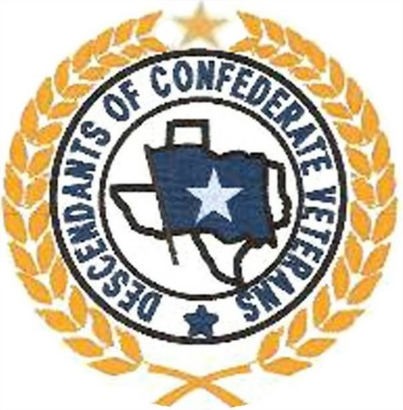

In light of all of the recent events concerning all things Confederate the Descendants of Confederate Veterans believes it necessary to make our position very clear. We deplore racism in all of its forms from any person, regardless of their skin color or background. We will not accept into membership a person who has ever been associated with any type of racial bias/hate group and will expel any member we find to have such involvement.
That being said, we also do not believe that the Confederate Battle Flag is responsible for the brutal murders in South Carolina. The murderer was also photographed holding a burning United States flag and Gold’s Gym shirts. We don’t hold them to blame either. The individual should be tried on the merits of the case, not on what he wore or what flag he happened to have in his hand when his photograph was taken. The racist sentiments he expressed were his own and should be taken as such. The removal of a Confederate flag in South Carolina has not ended racism any more than removal of monuments or renaming schools will.
The Descendants of Confederate Veterans is a genealogical, hereditary and memorial organization. Our members respect the ancestors who answered the call of their states and left home in defense of their loved ones. We also respect the memory of those who were left behind and those who never came home and those whose names are lost to history. Where someone offered themselves in defense of their hearth and home we believe it is appropriate to memorialize them. All gave some; some gave all.
We are determined to defend those ancestors who defended us so long ago. They are our family and we are honor bound to stand for them when they cannot. General Robert E. Lee said; “Do your duty in all things. You cannot do more. You should never wish to do less.” We see this as our duty.
We cannot instantly educate the masses on the history that they have been “mistaught” over 150 years but we do encourage them to educate themselves. But while we wait, we will not stand idly by while they either do or do not.
We will defend our families both past and present…as they defended theirs.

